**Gym Management System Data flow diagram**

Gym Management System Data flow diagram is often used as a preliminary step to create an overview of the Gym Management without going into great detail, which can later be [elaborated. It](http://elaborated.it/) normally consists of overall application dataflow and processes of the Gym Management process. It contains all of the user flow and their entities such all the flow of Gym, Gym Shift, Gym Facility, Package, Trainer, Payment, Branch. All of the below diagrams has been used for the visualization of data processing and structured design of the Gym Management process and working flow.  
  
**Zero Level Data Flow Diagram (0 Level DFD) Of Gym Management System:**  
This is the Zero Level DFD of Gym Management System, where we have elaborated the high level process of Gym Management. It's a basic overview of the whole Gym Management System or process being analysed or modelled. It's designed to be an at-a-glance view of Trainer, Payment and Branch showing the system as a single high-level process, with its relationship to external entities of Gym, Gym Shift and Gym Facility. It should be easily understood by a wide audience, including Gym, Gym Facility and Trainer In zero level DFD of Gym Management System, we have described the high level flow of the Gym Management system.  
  
High Level Entities and process flow of Gym Management System:

* Managing all the Gym
* Managing all the Gym Shift
* Managing all the Gym Facility
* Managing all the Package
* Managing all the Trainer
* Managing all the Payment
* Managing all the Branch

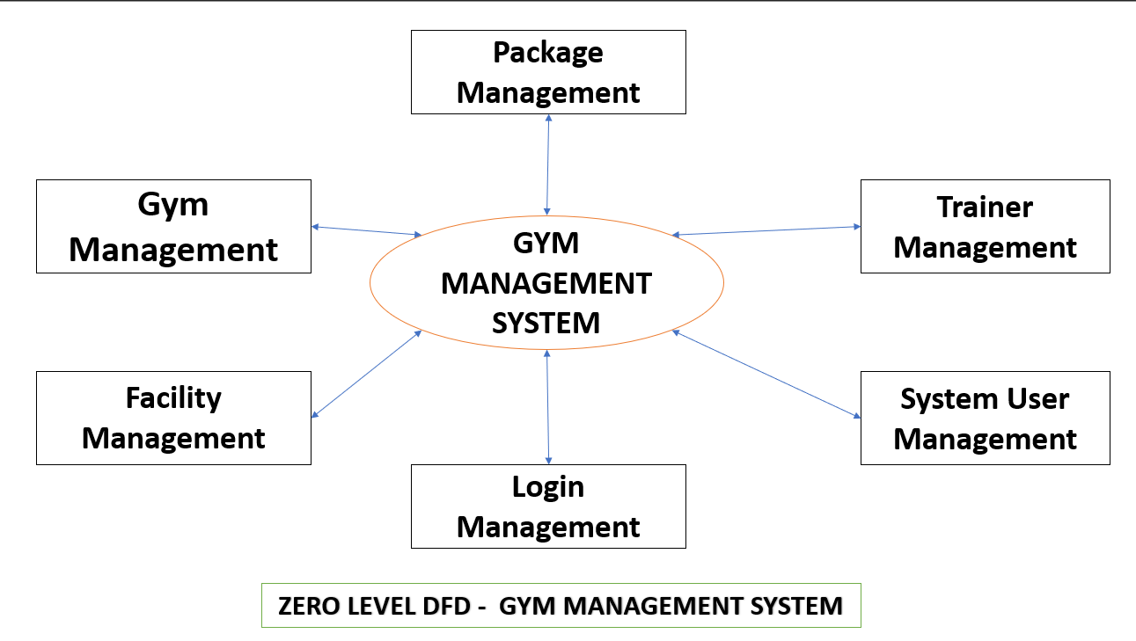

**First Level Data Flow Diagram(1st Level DFD) Of Gym Management System:**  
First Level DFD (1st Level) of Gym Management System shows how the system is divided into sub-systems (processes), each of which deals with one or more of the data flows to or from an external agent, and which together provide all of the functionality of the Gym Management System system as a whole. It also identifies internal data stores of Branch, Payment, Trainer, Package, Gym Facility that must be present in order for the Gym Management system to do its job, and shows the flow of data between the various parts of Gym, Gym Facility, Payment, Branch, Trainer of the system. DFD Level 1 provides a more detailed breakout of pieces of the 1st level DFD. You will highlight the main functionalities of Gym Management.  
  
Main entities and output of First Level DFD (1st Level DFD):

* Processing Gym records and generate report of all Gym
* Processing Gym Shift records and generate report of all Gym Shift
* Processing Gym Facility records and generate report of all Gym Facility
* Processing Package records and generate report of all Package
* Processing Trainer records and generate report of all Trainer
* Processing Payment records and generate report of all Payment
* Processing Branch records and generate report of all Branch

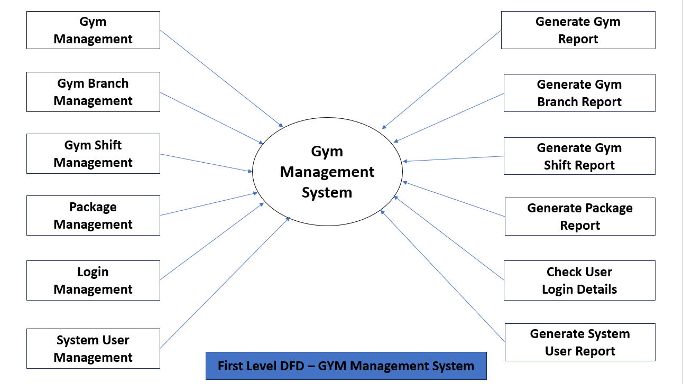

**Second Level Data Flow Diagram (2nd Level DFD) Of Gym Management System:**  
DFD Level 2 then goes one step deeper into parts of Level 1 of Gym Management. It may require more functionalities of Gym Management to reach the necessary level of detail about the Gym Management functioning. First Level DFD (1st Level) of Gym Management System shows how the system is divided into sub-systems (processes). The 2nd Level DFD contains more details of Branch, Payment, Trainer, Package, Gym Facility, Gym Shift, Gym.  
  
Low level functionalities of Gym Management System

* Admin logins to the system and manage all the functionalities of Gym Management System.
* Admin can add, edit, delete and view the records of Gym, Gym Facility, Trainer, Branch.
* Admin can manage all the details of Gym Shift, Package, Payment.
* Admin can also generate reports of Gym, Gym Shift, Gym Facility, Package, Trainer, Payment.
* Admin can search the details of Gym Shift, Trainer, Payment.
* Admin can apply different level of filters on report of Gym, Package, Trainer.
* Admin can tracks the detailed information of Gym Shift, Gym Facility, Package, Trainer.

